1. Write a C program to accept a 2d array at run time and replace each matrix element with its

square root.

Code:

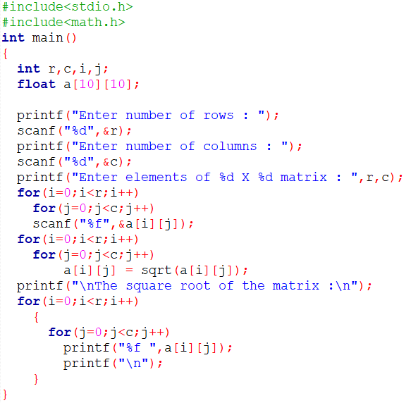

Output:

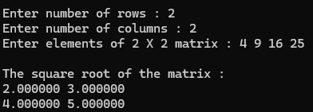

2. Write a C program to accept a 2d array at run time and perform scalar multiplication of this

matrix.

Code:

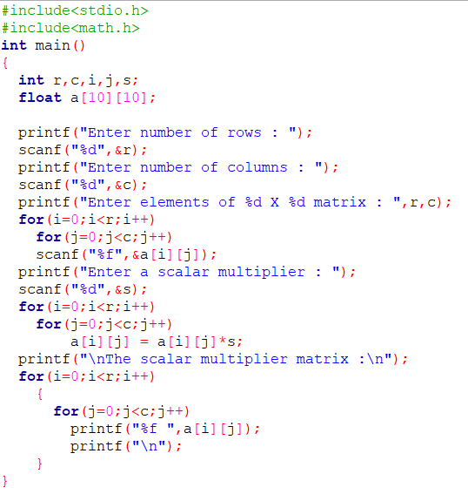

Output:

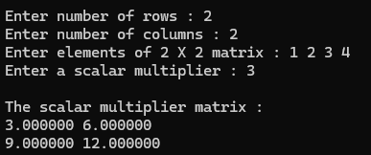

3. Write a C program to initialize a 2d array at compile time and find the minimum value in this

matrix.

Code:

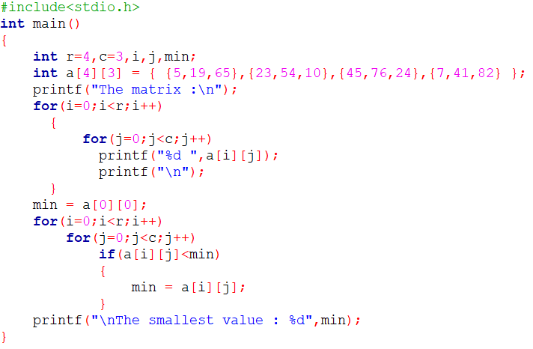

Output:

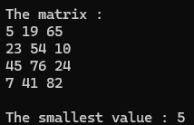

4. Write a C program to accept a 2d array at run time and to interchange any two rows of this

matrix.

Code:

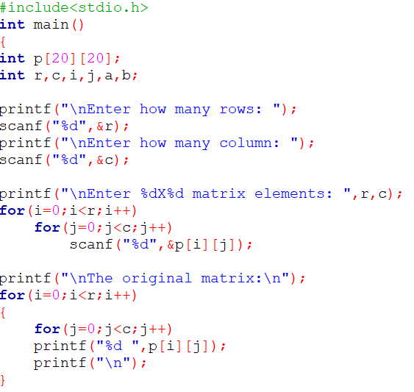

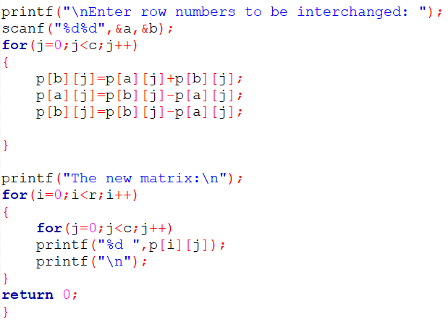

Output:

